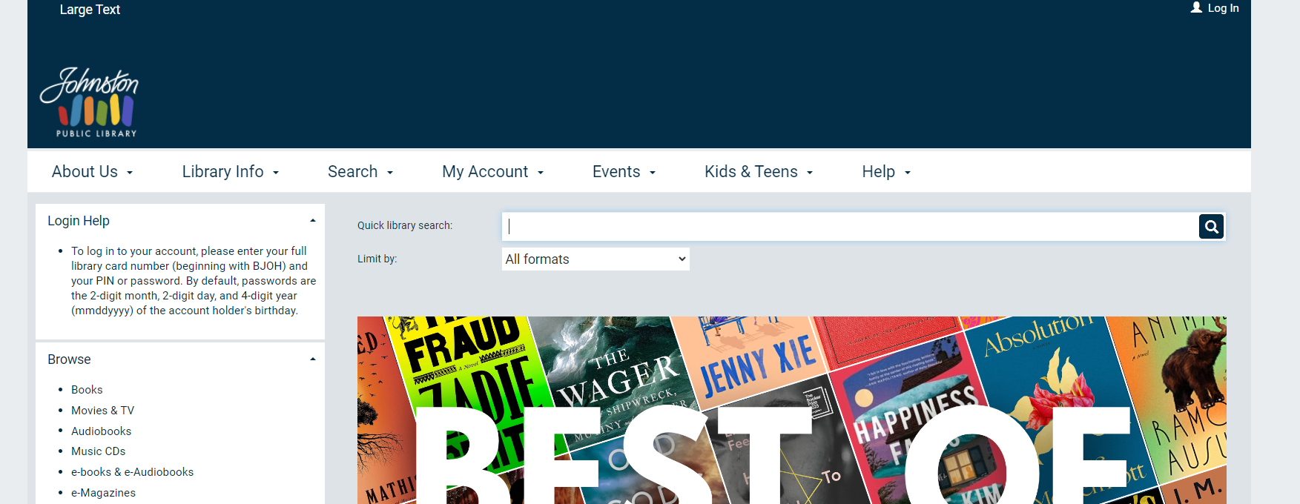

Log in to your account.

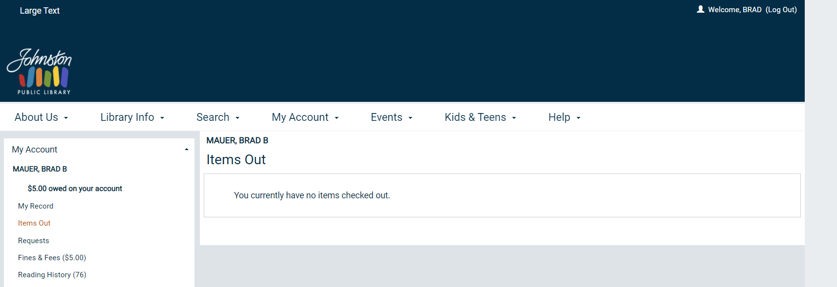

The easiest way to search is to click on the JPL logo in the top left-hand side of the screen. This will take you back to the landing page with the search bar shown above.