# How to Make a Reservation for a JPL Help Desk Appointment

* Determine what a person is seeking help with and whether a Help Desk Appointment is appropriate given the patron’s need.
* The *Inquiry for JPL Help Desk Related Flow Chart* can be used to determine if a Help Desk appointment is a reasonable solution or if a person would be better served by referring them to an outside resource.
* If a Help Desk appointment is appropriate, make an appointment for the patron.
* Help Desk appointments are 50 minutes in duration.
* Available appointment times for the JPL Help Desk are
  + Tuesdays from 4:00pm to 6:00pm and
  + Wednesdays from 10:00am to 12:00pm.
* Make sure you are logged in to johnston.librarycalendar.com/user/.

1. Click *Reserve a Room.*

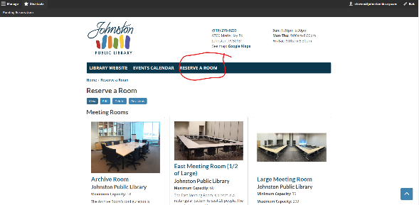

1. Scroll down until you see Library Use Only rooms and select Whisper Room or make a Tech Lab Reservation.

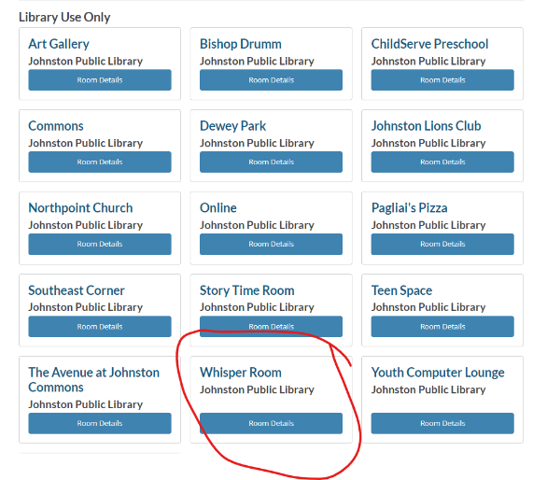

1. Title the reservation Help Desk Appointment regardless of its location (i.e. Whisper Room or Tech Lab).
2. Set the Reservation State is set to Pending.  
     
   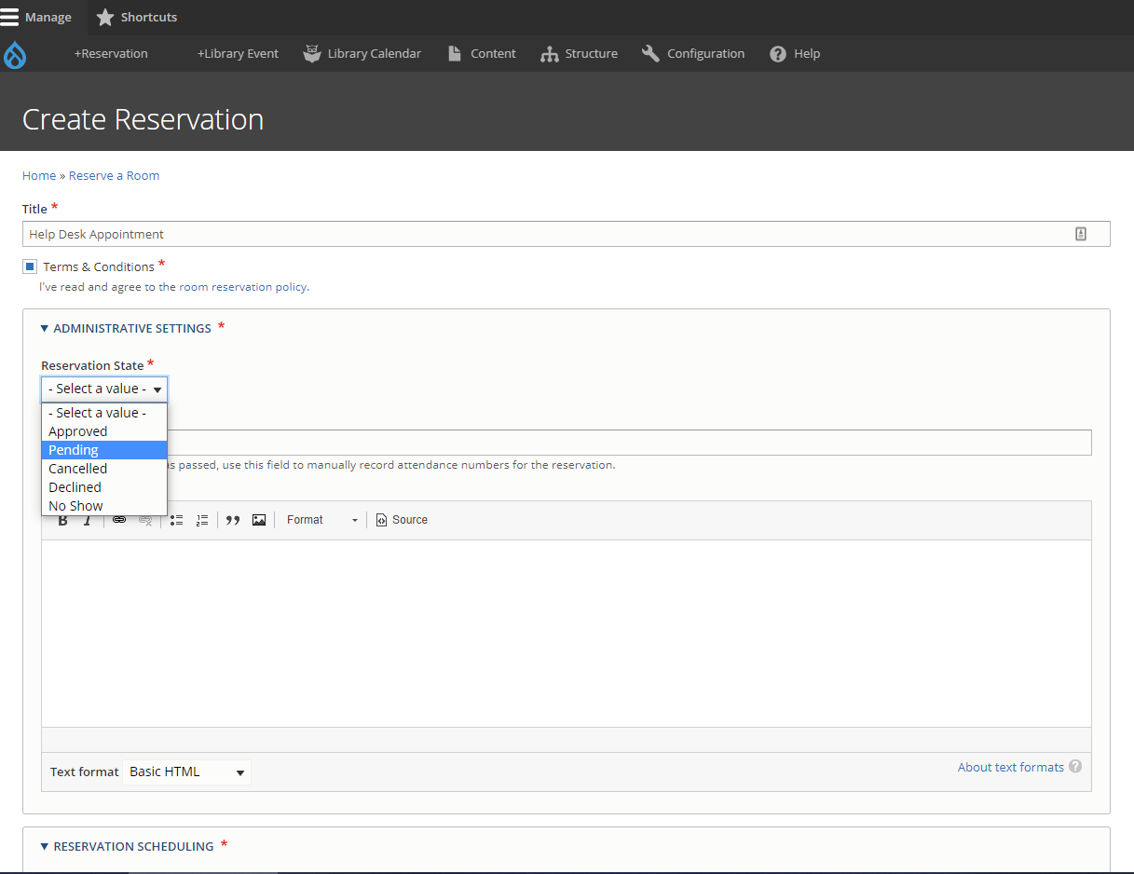

* Note: Help Desk appointments are for a duration of 50 minutes but the JPL calendar schedules in 15 minute increments so the appointment can be input into the calendar as a 1 hour appointment.

1. Enter the patron’s contact information in the form and provide a brief description in the *Special Requirements* field about what the patron wants to do during their appointment.
2. Submit.