**Patron Claims**

**Customer Claims Returned:**

(Before checking on shelf): Open Patron Record, highlight item, click on Make Claim, select Claim Returned.

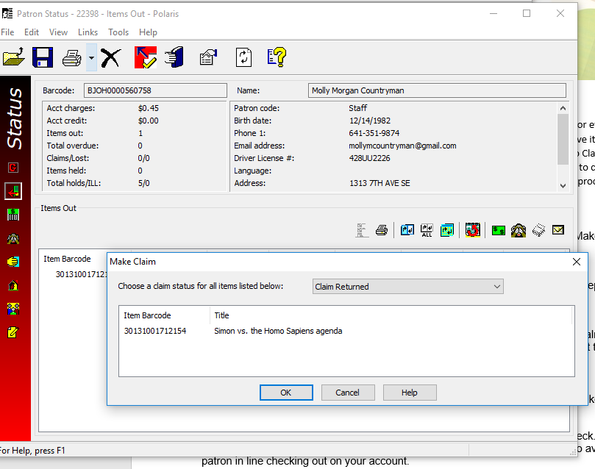

* Apologize for our error.
* What day do you believe you returned the item? Did you return it to the Beaver Creek or Horizon Book Return? If applicable, explain expected timeframe for items
* Item will be removed from your account and you will not be charged for its replacement cost.
* If you do find the item at any point in the future, please return it.
* Thank the patron for bringing the matter to our attention.