**A patron is interested in Food for Fines. How do I quickly find and add up the eligible fees on a patron’s account?**

Open the Patron Status window in the Account view (**TIP:** If you start in the Check Out Window, you can just double click on the Blocking Note that lists the fees owed)

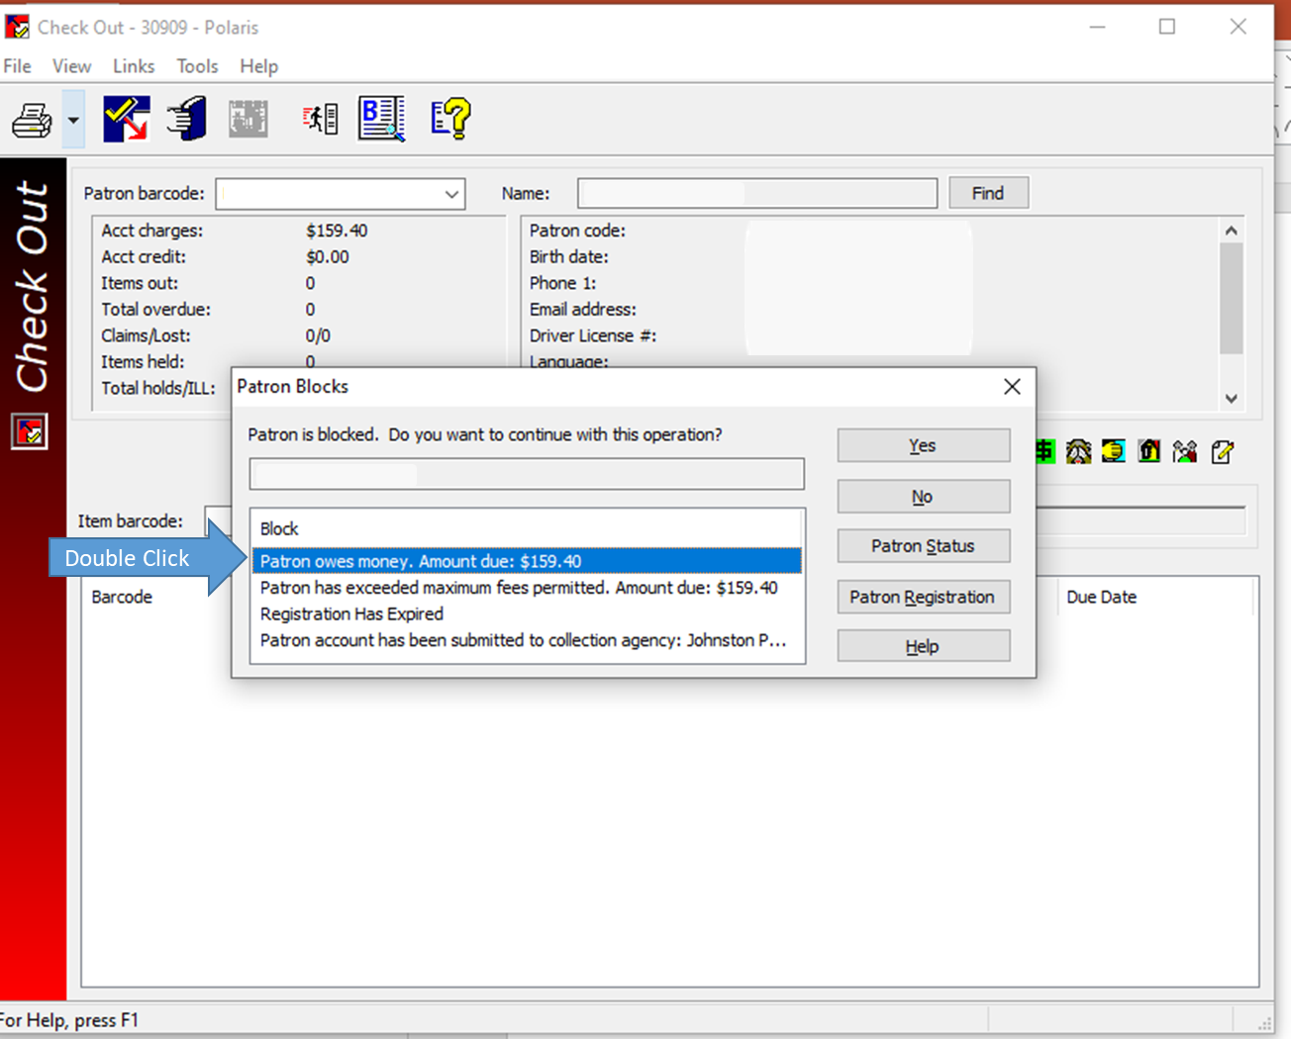

In the Patron Status window/Account view, you can sort the charges by clicking on the Reason column. Remember that Overdue Item = Fine and is eligible for Food for Fines.

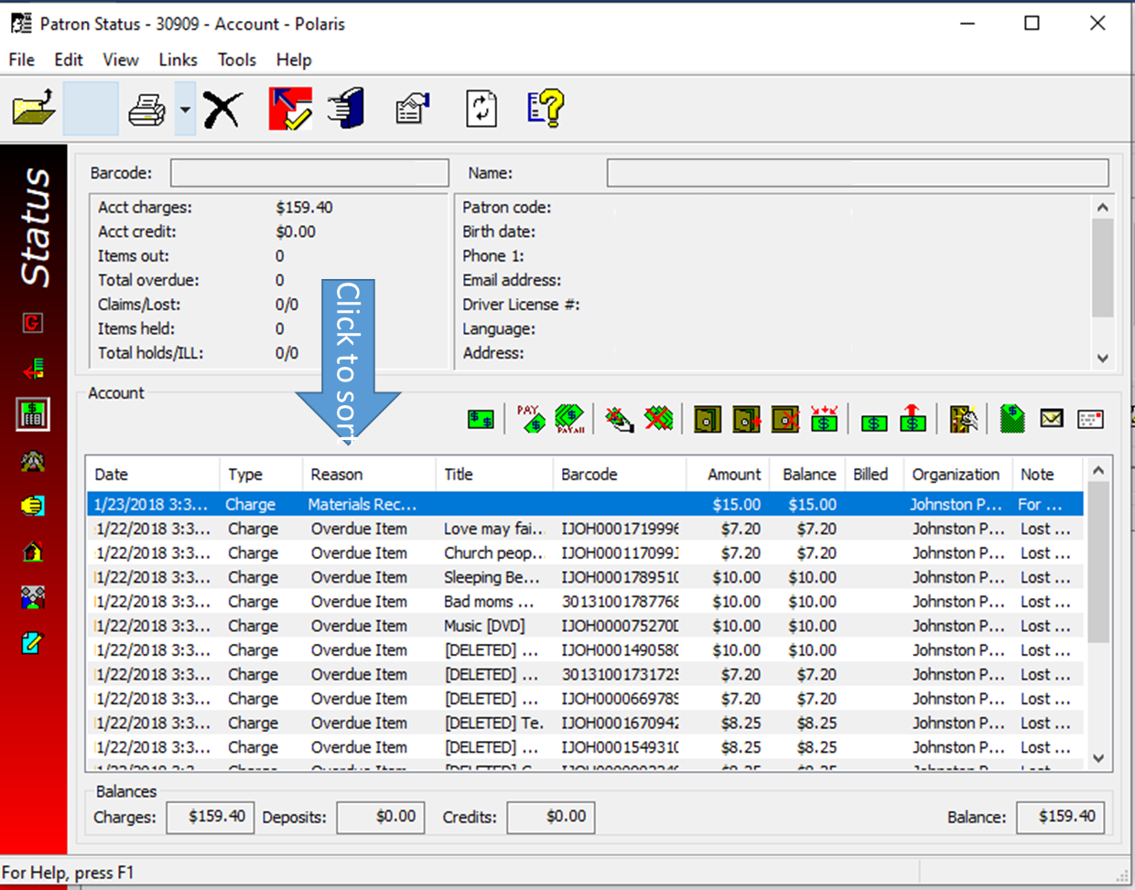

Highlight the Overdue Item charges after you have sorted the Reason column. (**TIP:** Click on the first Overdue Item charge, hold down the Shift key, click on the last overdue item)

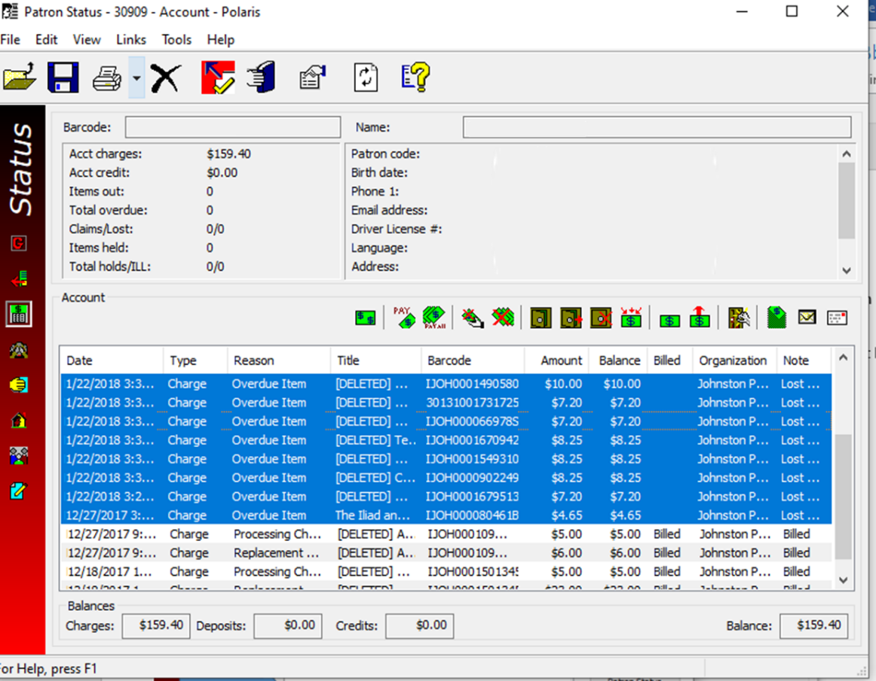

In the highlighted list, right click and select Pay.

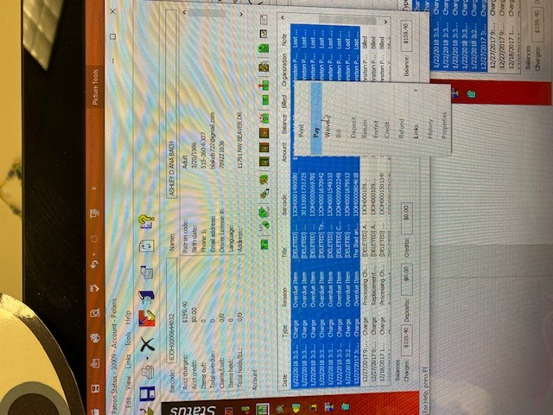

The Pay screen will have the total for the highlighted charges.

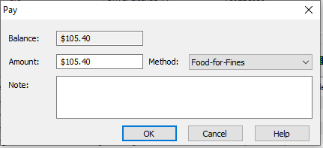

* If you were just getting the total amount due in fines, please click **Cancel,**
* If the patron is ready to pay with food/personal care items, please select Food-for-Fines from the Method menu and click OK.